Resnet 152 pretrained on imagenet
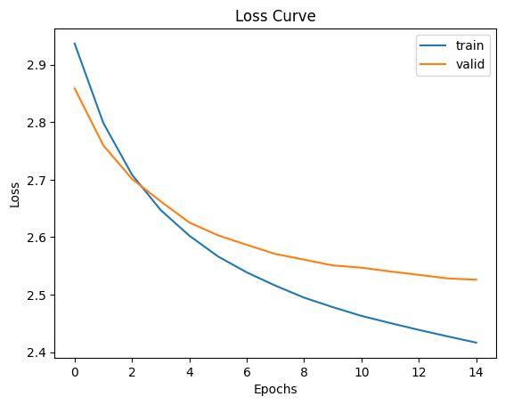

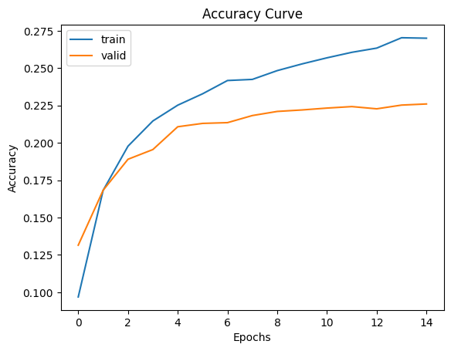

'macro_precision': tensor(0.2072),
'macro_recall': tensor(0.2264),
'macro_f1': tensor(0.2099),
'overall_accuracy': tensor(0.2251)}

Accuracy of Class 0: 0.0294
Accuracy of Class 1: 0.5435
Accuracy of Class 2: 0.2537
Accuracy of Class 3: 0.5314
Accuracy of Class 4: 0.2103
Accuracy of Class 5: 0.3094
Accuracy of Class 6: 0.0368
Accuracy of Class 7: 0.1435
Accuracy of Class 8: 0.3846
Accuracy of Class 9: 0.3472
Accuracy of Class 10: 0.3196
Accuracy of Class 11: 0.1515
Accuracy of Class 12: 0.2567
Accuracy of Class 13: 0.1343
Accuracy of Class 14: 0.1422
Accuracy of Class 15: 0.2271
Accuracy of Class 16: 0.1350
Accuracy of Class 17: 0.0441
Accuracy of Class 18: 0.1451
Accuracy of Class 19: 0.1956

RESNET 32 (NO PRE-TRAINING)

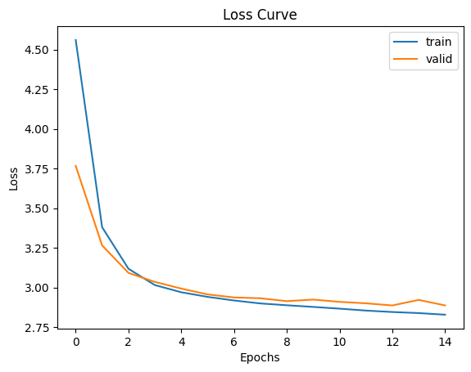
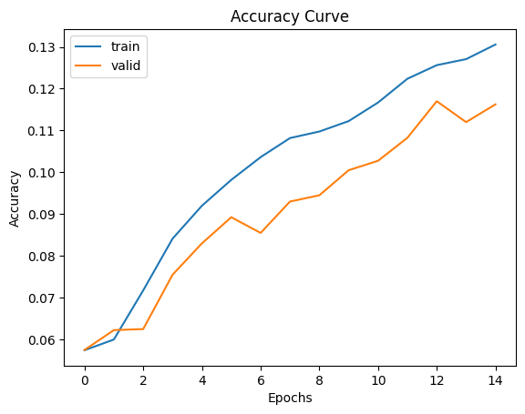

Accuracy of Class 0: 0.0118
Accuracy of Class 1: 0.3587
Accuracy of Class 2: 0.1443
Accuracy of Class 3: 0.4976
Accuracy of Class 4: 0.2150
Accuracy of Class 5: 0.0221
Accuracy of Class 6: 0.0474
Accuracy of Class 7: 0.1053
Accuracy of Class 8: 0.2212
Accuracy of Class 9: 0.0415
Accuracy of Class 10: 0.0000
Accuracy of Class 11: 0.2374
Accuracy of Class 12: 0.0321
Accuracy of Class 13: 0.0050
Accuracy of Class 14: 0.0332
Accuracy of Class 15: 0.1256
Accuracy of Class 16: 0.0800
Accuracy of Class 17: 0.0000
Accuracy of Class 18: 0.0104
Accuracy of Class 19: 0.1111

'macro_precision': tensor(0.1041),
'macro_recall': tensor(0.1147),
'macro_f1': tensor(0.0870),
'overall_accuracy': tensor(0.1154)}

Vit_b_16 pretrained on imagenet (lr=0.0001, w_decay = 0.0005, batch size=512, epochs=30)
Lr reduces by 25% every 10 epochs, weight decay increases by 25% every 10 epochs

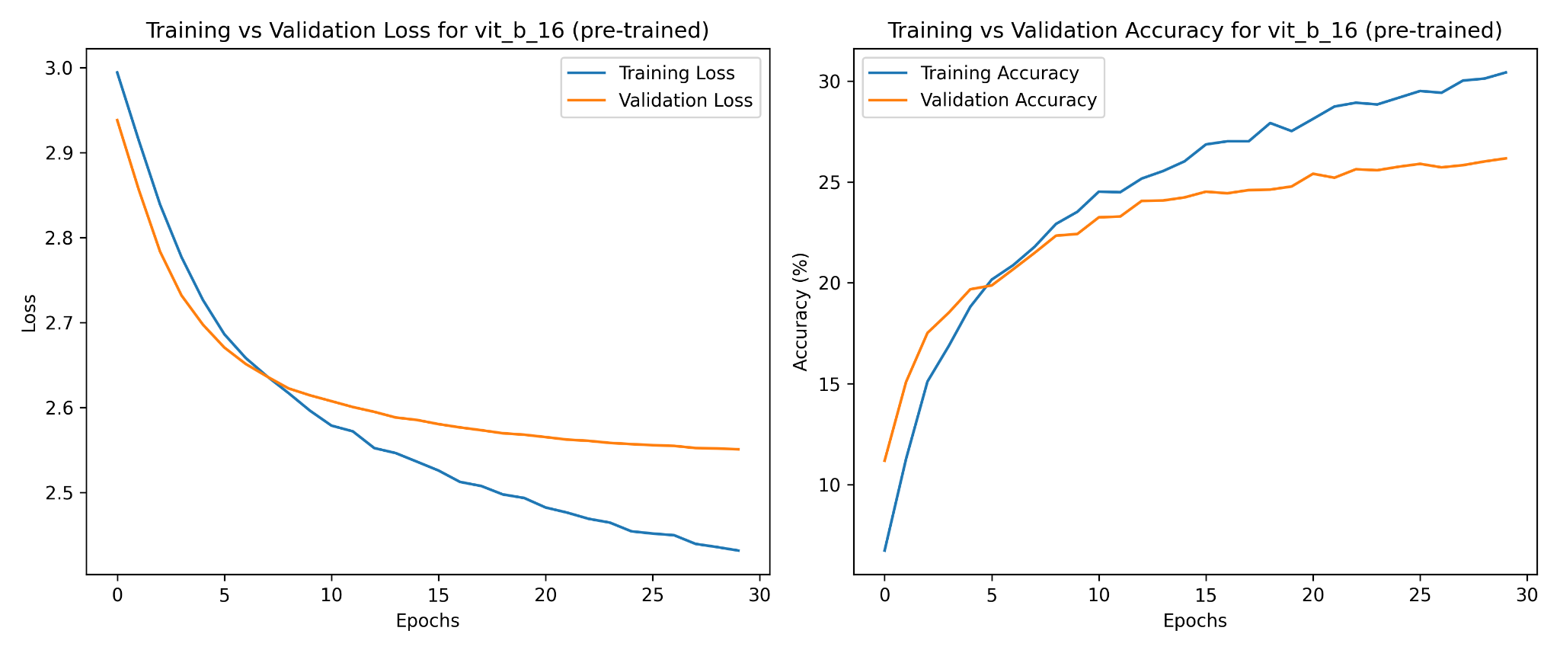
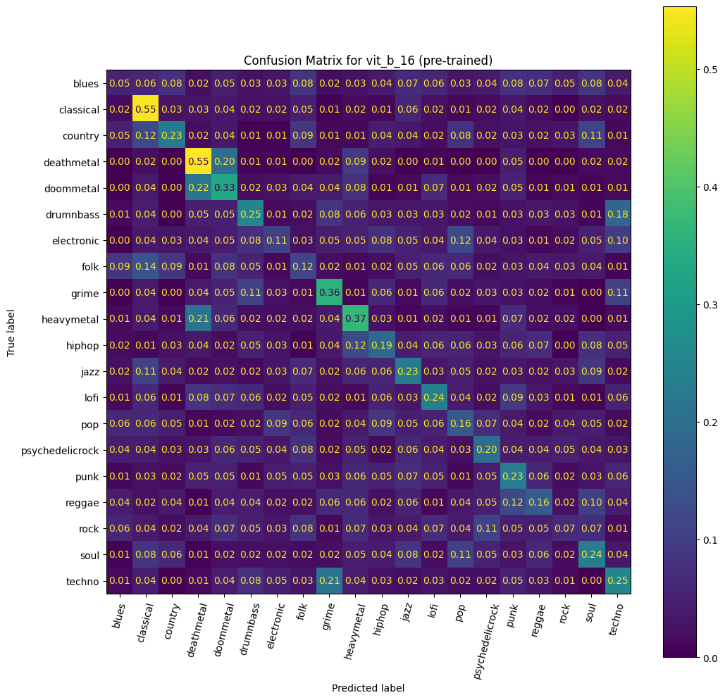

Test Accuracy: 24.38%
Test Precision: 22.88%
Test Recall: 24.38%
Test F1 Score: 23.14%

Class 0 acc: 0.05228758
Class 1 acc: 0.54761905
Class 2 acc: 0.22981366
Class 3 acc: 0.5530303
Class 4 acc: 0.32894737
Class 5 acc: 0.25174825
Class 6 acc: 0.10967742
Class 7 acc: 0.11564626
Class 8 acc: 0.35810811
Class 9 acc: 0.36734694
Class10 acc: 0.1910828
Class11 acc: 0.2295082
Class12 acc: 0.23776224
Class13 acc: 0.15748031
Class14 acc: 0.2
Class15 acc: 0.23225806
Class16 acc: 0.1595092
Class17 acc: 0.06622517
Class18 acc: 0.23529412
Class19 acc: 0.25342466

Vit_b_16 no pre training (lr=0.0001, w_decay = 0.0005, batch size=32, epochs=30)
Lr reduces by 25% every 10 epochs, weight decay increases by 25% every 10 epochs
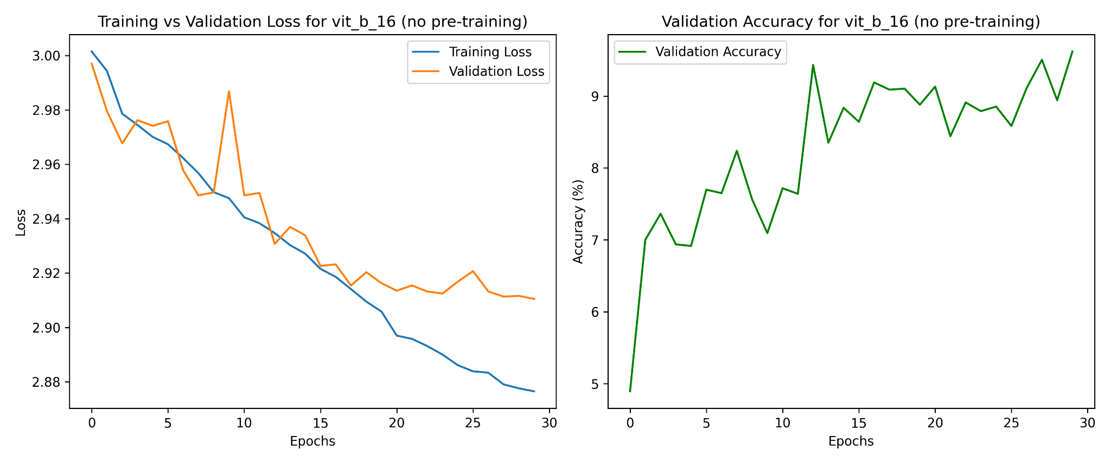
Test Accuracy: 10.35%
Test Precision: 8.71%
Test Recall: 10.35%
Test F1 Score: 8.24%

Class 0 acc:0.03921569
Class 1 acc:0.125
Class 2 acc:0.11801242
Class 3 acc:0.37121212
Class 4 acc:0.27631579
Class 5 acc:0.02097902
Class 6 acc:0.01290323
Class 7 acc:0.10884354
Class 8 acc:0.14864865
Class 9 acc:0.19047619
Class10 acc:0.
Class11 acc:0.
Class12 acc:0.25874126
Class13 acc:0.00787402
Class14 acc:0.05
Class15 acc:0.07096774
Class16 acc:0.07361963
Class17 acc:0.
Class18 acc:0.05294118
Class19 acc:0.14383562

Efficient net-b2 (without using pre-training model):
Checkpoint Test Metrics:
Accuracy: 12.61%
Precision (macro): 13.43%
Recall (macro): 12.61%
F1 Score (macro): 12.63%

Per-Class Accuracy:
Class 0: 0.0261
Class 1: 0.2560
Class 2: 0.1242
Class 3: 0.2348
Class 4: 0.2829
Class 5: 0.0979
Class 6: 0.0194
Class 7: 0.1701
Class 8: 0.2230
Class 9: 0.1361
Class 10: 0.0637
Class 11: 0.0738
Class 12: 0.1538
Class 13: 0.0709
Class 14: 0.0813
Class 15: 0.0774
Class 16: 0.1534
Class 17: 0.0331
Class 18: 0.1000
Class 19: 0.1438

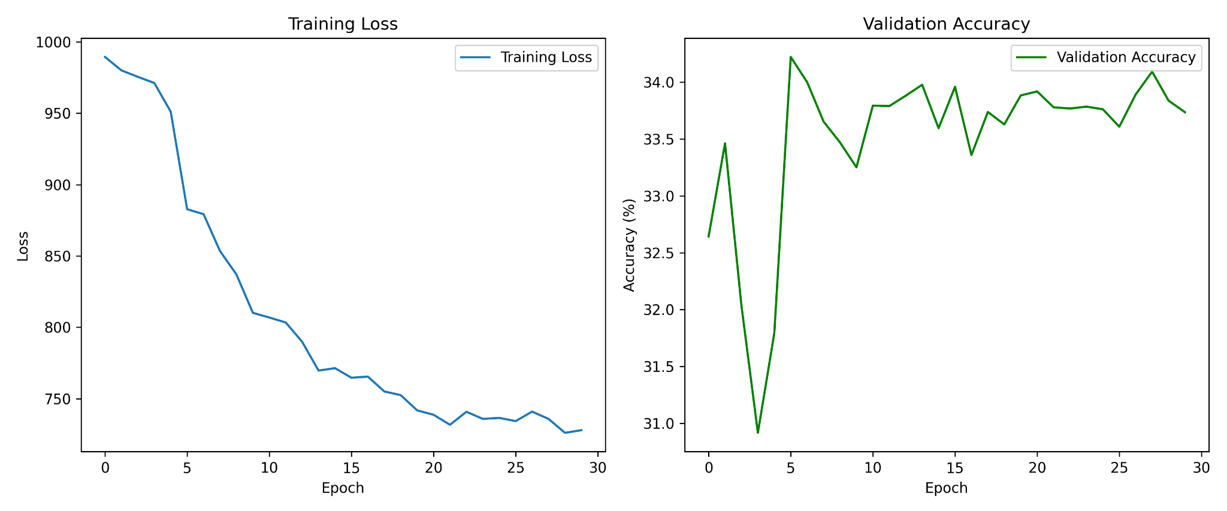

Efficientnet-b2(with pre-training model):
Checkpoint Test Metrics:
Accuracy: 33.33%
Precision (macro): 32.94%
Recall (macro): 33.33%
F1 Score (macro): 32.99%

Per-Class Accuracy:
Class 0: 0.1895
Class 1: 0.5238
Class 2: 0.3975
Class 3: 0.6515
Class 4: 0.3750
Class 5: 0.4476
Class 6: 0.1355
Class 7: 0.2381
Class 8: 0.5068
Class 9: 0.4354
Class 10: 0.3057
Class 11: 0.3115
Class 12: 0.3497
Class 13: 0.1181
Class 14: 0.2500
Class 15: 0.3226
Class 16: 0.3742
Class 17: 0.0927
Class 18: 0.3059
Class 19: 0.3356
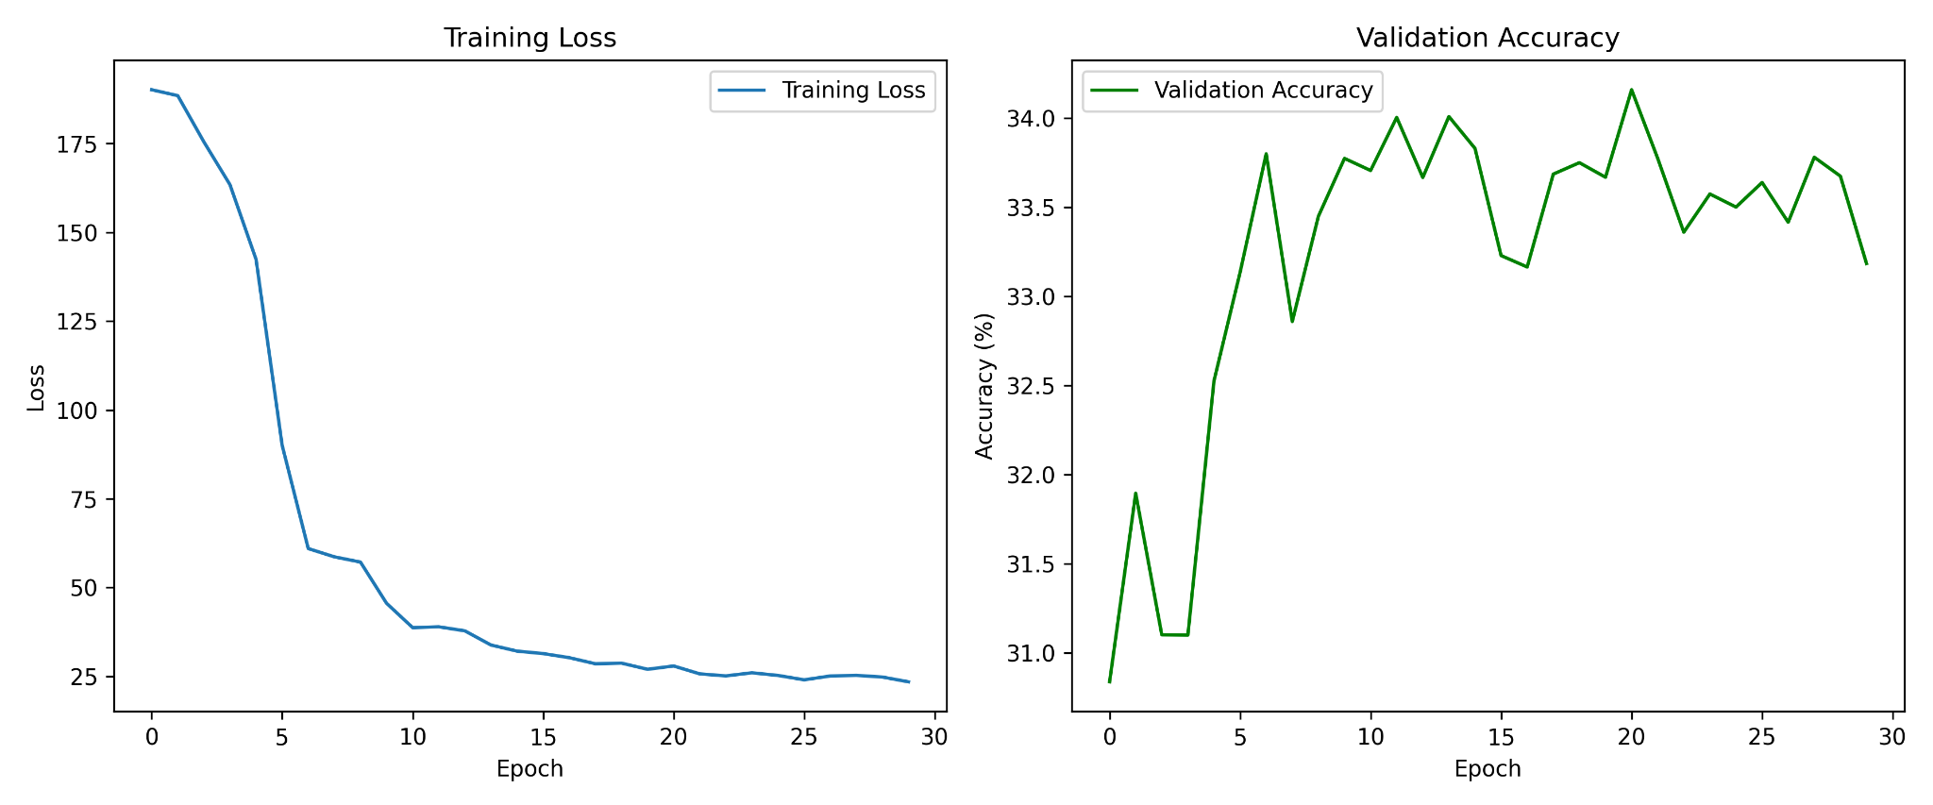

Our models consisted of deep neural networks including ResNet152, ResNet32, ViT B16, and EfficientNet-B2, with both pretrained and non-pretrained variants. The learned parameters in each model were primarily contained within the convolutional (or self-attention) layers responsible for hierarchical feature extraction. For pretrained models, the base architectures were initialized with ImageNet weights and fine-tuned by replacing and training the final classification layer. Non-learned components included the final post-processing step, where raw model outputs (logits) were converted to class predictions using the argmax function applied over softmax outputs during evaluation. This step was purely deterministic and had no trainable parameters.

Preprocessing
The models expected input images in the shape of three-channel RGB tensors, resized to 224×224 pixels to match the input dimensions of ImageNet-pretrained networks. While our raw album cover images were initially sized at 300×300 pixels, we resized them during preprocessing; however, we did not apply further normalization or pixel-wise standardization (e.g., ImageNet mean/std normalization), which could have improved model convergence. Labels were encoded as integer class indices for each genre and passed to the loss function in this format.

Loss
We trained the models using CrossEntropyLoss, which is appropriate for multi-class classification tasks. Optimization was performed using the Adam optimizer with a learning rate of 0.0001, batch size of 256, and weight decay of 0.0001. These hyperparameters were selected empirically based on convergence stability and GPU memory constraints. While a learning rate scheduler was available in our pipeline, we focus our analysis on fixed learning rate behavior across 15 training epochs for comparability.

Summary
In terms of generalization, models trained from scratch (e.g., ResNet32 and ViT without pretraining) tended to overfit, achieving low validation accuracy and poor average class performance (around 10–11%). In contrast, pretrained models—particularly
EfficientNet-B2—showed markedly better generalization, with an average class accuracy of 33.3%, outperforming both ResNet152 (22.7%) and ViT B16 (24.4%). Despite these improvements, genre confusion remained high in visually ambiguous classes like rock, hip-hop, and electronic, suggesting inherent limitations of using album artwork alone for genre classification.

Framework
All experiments were implemented in PyTorch, leveraging torchvision for pretrained model access and model definition. PyTorch's modular design allowed seamless customization of model heads and training loops, as well as integration with GPU acceleration for efficient training.

